## Reports/ Rx Reports/ Early Refill For Controlled Drugs Report:

Request:

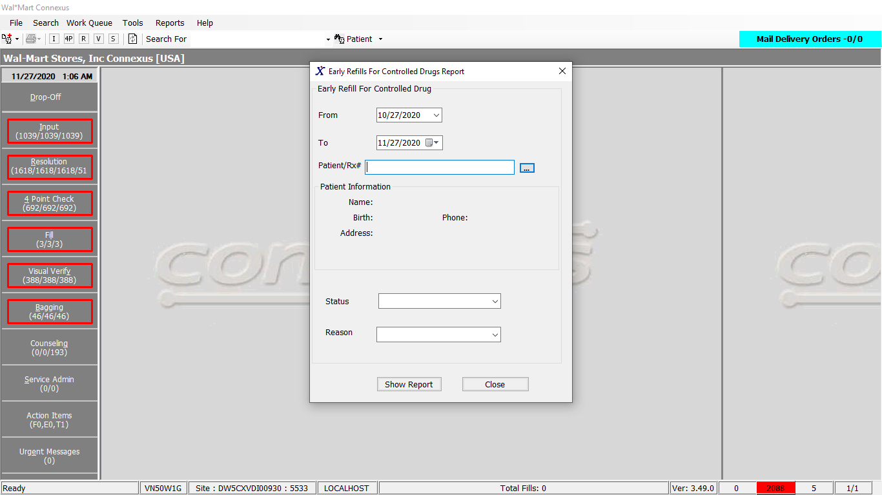

Response:

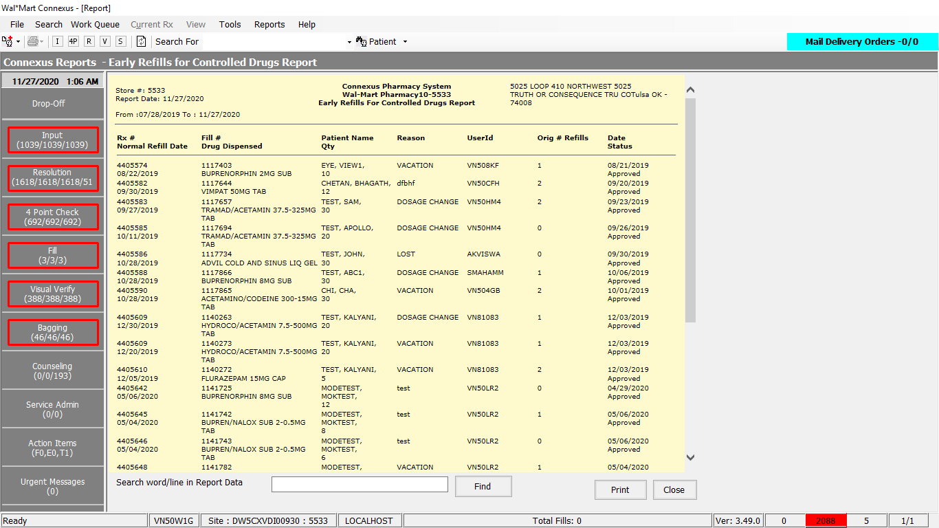

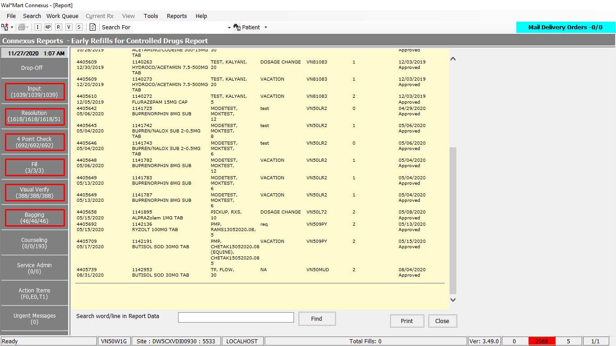

Queries:

Friend Const GetEarlyRefillControlled As String = " select unique rx.rx_nbr, rf.rx_fill_id, trim(nvl(p.last_name,'')) || ', ' || trim(nvl(p.first_name,''))|| ', ' || trim(nvl(p.middle_name,'')) patientname,aa.activity_comment Reason, aa1.activity_id FirstAct, aa2.activity_id SecondAct, rf.fill_date,rf.fill_qty , pp.product_name,pp.short_name, rx.rx_written_date , aa1.userid userid,rx.refills_auth_nbr MaxNoRefills FROM rx rx, patient p, rx_fill rf,error_and_audit:appl_actv_subject acs, error_and_audit:appl_actv_subject acs1,error_and_audit:appl_actv_subject acs2,error_and_audit: appl_activity aa, error_and_audit: appl_activity aa1, error_and_audit: appl_activity aa2, pharmacy_offering: pharmacy_product pp WHERE rx.Patient_Id = P.Patient_Id And rx.rx_id = rf.rx_id and acs.subject_id = rf.rx_fill_id and acs1.subject_id = rf.rx_fill_id and acs2.subject_id = rf.rx_fill_id and acs.activity_id = aa.activity_id and acs1.activity_id = aa1.activity_id and acs2.activity_id = aa2.activity_id and aa2.task_id = ? and pp.product_mds_fam_id=rx.product_mds_fam_id and ( pp.drug_control_code in (2301,2302,2303) or (SELECT restrict_value From pharmacy_offering: phm_item_restrict WHERE mds_fam_id = (select item_mds_fam_id from rx_fill_item rfi,rx rx Where rfi.rx_fill_id = rx.last_rx_fill_id AND rx.rx_id = rf.rx_id) AND effective_date <= current AND restrict_Type_code =? AND (expiration_date is NULL or expiration_date > current) ) = 'TRUE') and rf.fill_date between ? and ? "

DAL:

Public Function GetEarlyRefillControlled(ByVal siteId As Integer, ByVal startDate As Date,

ByVal endDate As Date, Optional ByVal patientId As Integer = 0,

Optional ByVal status As Integer = 0, Optional ByVal reason As Integer = 0,

Optional ByVal rxNbr As Integer = 0) As List(Of EarlyRefillControlledBE) Implements IReportDAL.GetEarlyRefillControlled

Using (New Tracer(ConnexusCommonConstants.ConnexusTracer))

Dim sqlString As New StringBuilder

Dim earlyRefillControlledData As EarlyRefillControlledBE

Dim earlyRefillDataList As New List(Of EarlyRefillControlledBE)

sqlString.Append(ReportQueries.GetEarlyRefillControlled)

Dim paramList As New List(Of DbParameter)

paramList.Add(ParameterHelper.BuildParameter("TaskId", DbType.Int32, ServicesCommonConstants.EarlyRefillTskNormalRefillDate))

paramList.Add(ParameterHelper.BuildParameter("RestrictTypeCode", DbType.Int32, ServicesCommonConstants.EarlyRefillPhmItem))

paramList.Add(ParameterHelper.BuildParameter("startDate", DbType.Date, startDate))

paramList.Add(ParameterHelper.BuildParameter("endDate", DbType.Date, endDate))

If patientId > 0 Then

sqlString.Append(" and p.patient_id= ? ")

paramList.Add(ParameterHelper.BuildParameter("PatientId", DbType.Int32, patientId))

End If

If rxNbr > 0 Then

sqlString.Append(" and rx.Rx_nbr= ?")

paramList.Add(ParameterHelper.BuildParameter("RxNbr", DbType.Int32, rxNbr))

End If

If status > 0 Then

sqlString.Append(" and aa1.error_id= ? and aa1.task_id = ? ")

paramList.Add(ParameterHelper.BuildParameter("Status", DbType.Int32, status))

paramList.Add(ParameterHelper.BuildParameter("TaskId", DbType.Int32, ServicesCommonConstants.EarlyRefillTskStatus))

Else

sqlString.Append(" and aa1.task_id =? ")

paramList.Add(ParameterHelper.BuildParameter("TaskId", DbType.Int32, ServicesCommonConstants.EarlyRefillTskStatus))

End If

If reason > 0 Then

sqlString.Append(" and aa.error_id= ? and aa.task_id = ? ")

paramList.Add(ParameterHelper.BuildParameter("Reason", DbType.Int32, reason))

paramList.Add(ParameterHelper.BuildParameter("TaskId", DbType.Int32, ServicesCommonConstants.EarlyRefillTskReason))

Else

sqlString.Append(" and aa.task_id = ? ")

paramList.Add(ParameterHelper.BuildParameter("TaskId", DbType.Int32, ServicesCommonConstants.EarlyRefillTskReason))

End If

Dim dataReader As IDataReader = ExecuteReader(DatabaseEnum.rx21c,

siteId, sqlString.ToString, paramList)

While dataReader.Read

earlyRefillControlledData = New EarlyRefillControlledBE

If Not dataReader.IsDBNull(dataReader.GetOrdinal("rx_nbr")) Then

earlyRefillControlledData.RxNumber = Convert.ToInt32(dataReader("rx_nbr"), CultureInfo.InvariantCulture)

End If

If Not dataReader.IsDBNull(dataReader.GetOrdinal("rx_fill_id")) Then

earlyRefillControlledData.RxFillId = Convert.ToInt32(dataReader("rx_fill_id"), CultureInfo.InvariantCulture)

End If

If Not dataReader.IsDBNull(dataReader.GetOrdinal("patientname")) Then

earlyRefillControlledData.PatientName = Convert.ToString(dataReader("patientname"), CultureInfo.InvariantCulture)

End If

If Not dataReader.IsDBNull(dataReader.GetOrdinal("Reason")) Then

earlyRefillControlledData.Reason = Convert.ToString(dataReader("Reason"), CultureInfo.InvariantCulture)

End If

'Start Hipaa Changes

'Changes for geting status

If Not dataReader.IsDBNull(dataReader.GetOrdinal("FirstAct")) Then

earlyRefillControlledData.Status = GetEarlyFillStatus(siteId, CInt(dataReader("FirstAct")))

End If

'Changes for geting NormalFillDate

If Not dataReader.IsDBNull(dataReader.GetOrdinal("SecondAct")) Then

earlyRefillControlledData.NormalFillDate = GetEarlyFillNormalFillDate(siteId, CInt(dataReader("SecondAct")))

End If

'End Hipaa Changes

If Not dataReader.IsDBNull(dataReader.GetOrdinal("fill_date")) Then

earlyRefillControlledData.FillDate = Convert.ToDateTime(dataReader("fill_date"), CultureInfo.InvariantCulture)

End If

If Not dataReader.IsDBNull(dataReader.GetOrdinal("fill_qty")) Then

earlyRefillControlledData.FillQty = Convert.ToInt32(dataReader("fill_qty"), CultureInfo.InvariantCulture)

End If

If Not dataReader.IsDBNull(dataReader.GetOrdinal("product_name")) Then

earlyRefillControlledData.ProductName = Convert.ToString(dataReader("product_name"), CultureInfo.InvariantCulture)

End If

If Not dataReader.IsDBNull(dataReader.GetOrdinal("rx_written_date")) Then

earlyRefillControlledData.RxWrittenDate = Convert.ToDateTime(dataReader("rx_written_date"), CultureInfo.InvariantCulture)

End If

If Not dataReader.IsDBNull(dataReader.GetOrdinal("userid")) Then

earlyRefillControlledData.UserId = Convert.ToString(dataReader("userid"), CultureInfo.InvariantCulture)

End If

If Not dataReader.IsDBNull(dataReader.GetOrdinal("MaxNoRefills")) Then

earlyRefillControlledData.MaxNoRefills = Convert.ToInt32(dataReader("MaxNoRefills"), CultureInfo.InvariantCulture)

End If

'RI specific Controlled Substance Early Refill Warnings Start

'Description : Display drug dispensed name in Early refills for controlled drugs report

If Not dataReader.IsDBNull(dataReader.GetOrdinal("short_name")) Then

earlyRefillControlledData.DispensedProduct = Convert.ToString(dataReader("short_name"), CultureInfo.InvariantCulture)

End If

'RI specific Controlled Substance Early Refill Warnings End

earlyRefillDataList.Add(earlyRefillControlledData)

End While

If earlyRefillDataList.Count > 0 Then

Return earlyRefillDataList

Else

Return Nothing

End If

End Using

End Function